**Python program using simple statement and expression**

**Ex.no 2a PERFORM ARITHMETIC OPERATION**

**PROGRAM:**

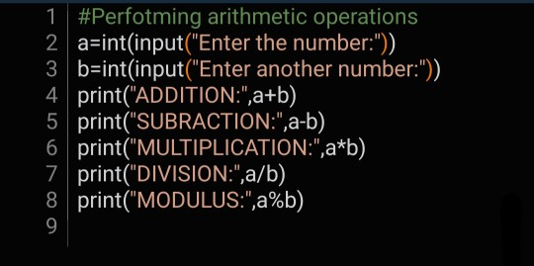

**OUTPUT:**

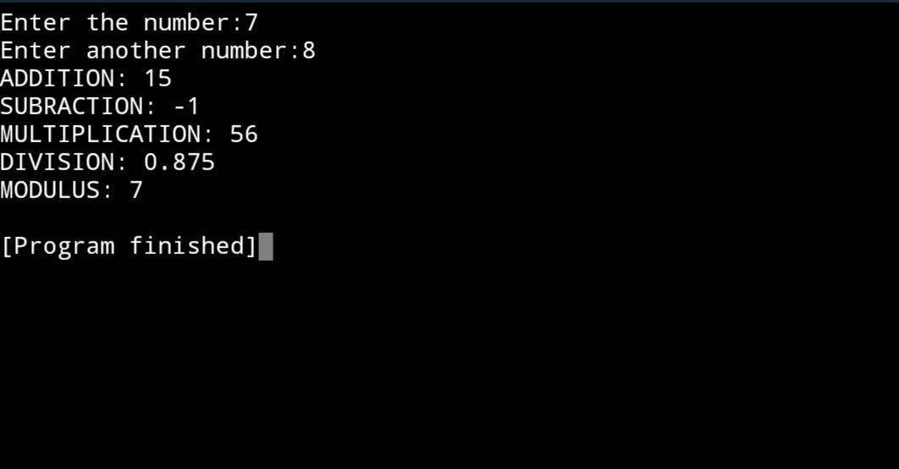

**Ex.no.2b WEIGHT AND TOTAL COST OF APPLE**

**PROGRAM:**

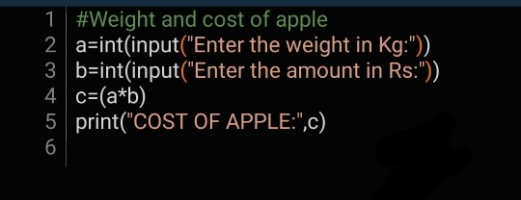

**OUTPUT:**

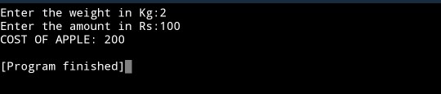

**Ex.no.2c DISCOUNT ON BOOKS**

**PROGRAM:**

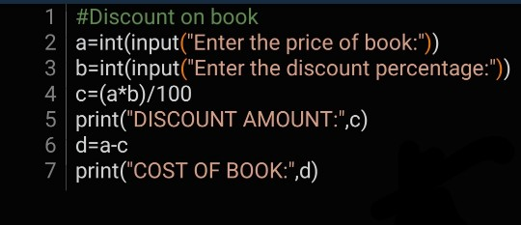

**OUTPUT:**

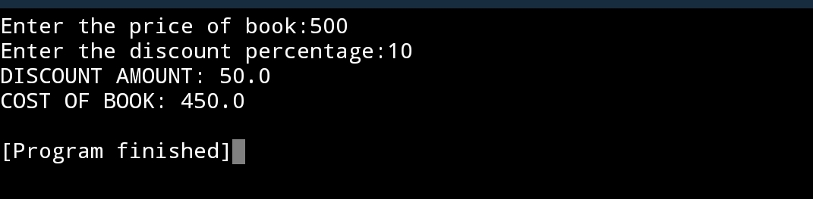

**Ex.no.2d CONVERT FAHRENHEIT TO CELSIUS**

**PROGRAM:**

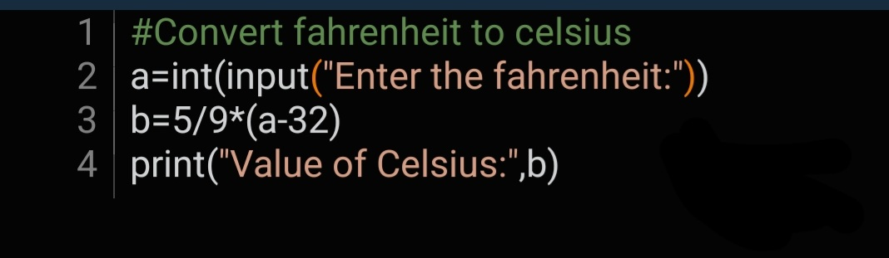

**OUTPUT:**

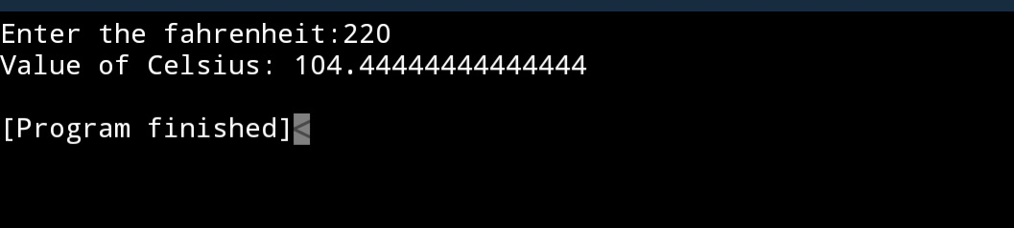

**Ex.no.2e DISTANCE BETWEEN TWO POINTS**

**PROGRAM:** 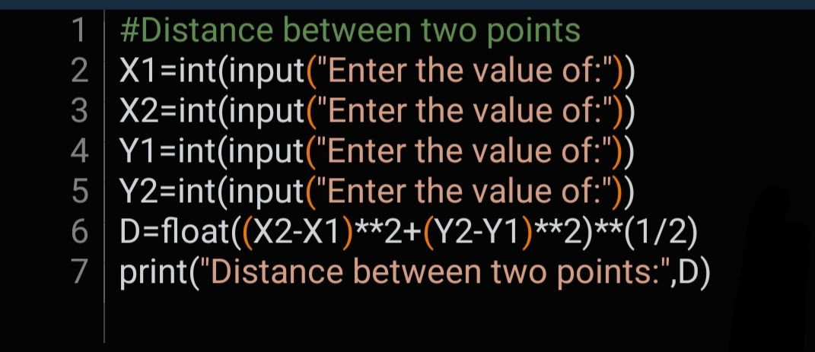

**OUTPUT:**

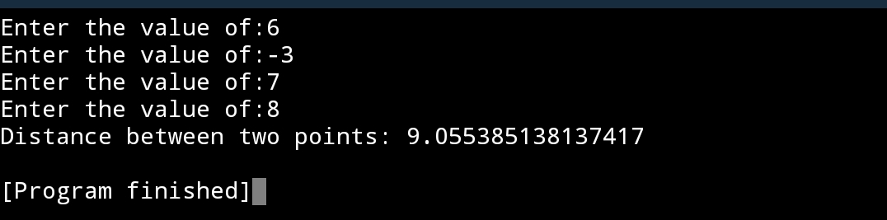

**Ex.no.2f SWAPPING OF VALUES**

**PROGRAM:**

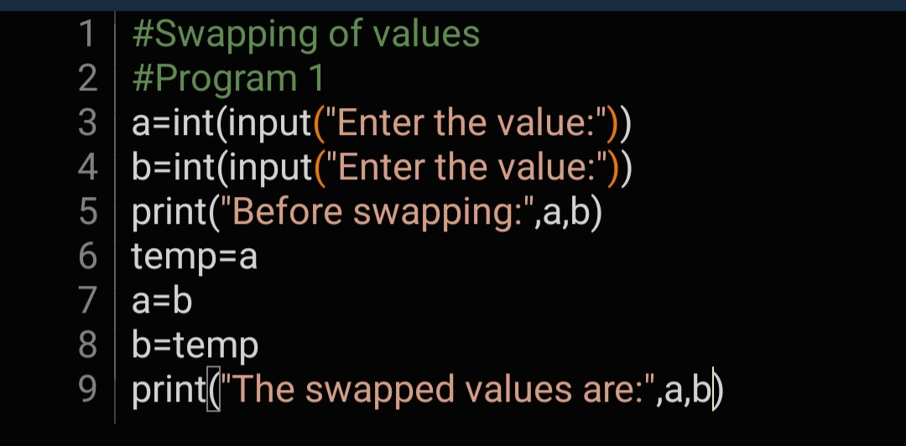

**OUTPUT:**

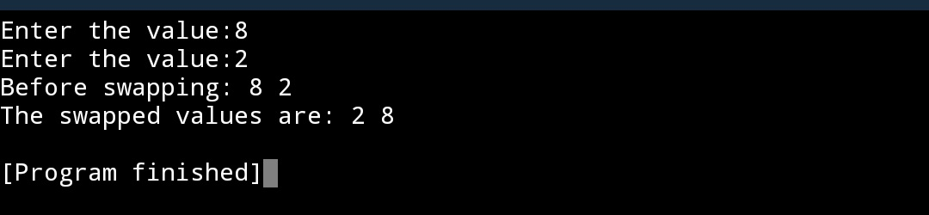

**PROGRAM:**

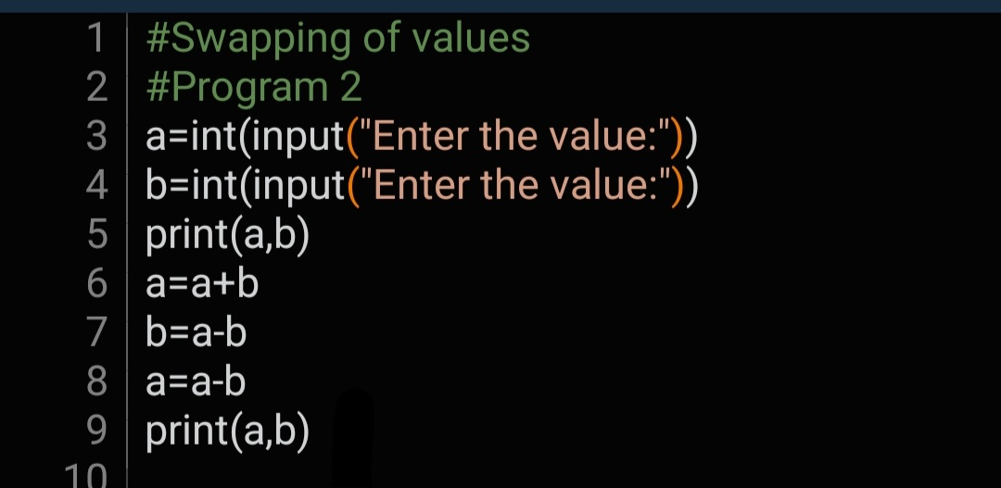

**OUTPUT:**

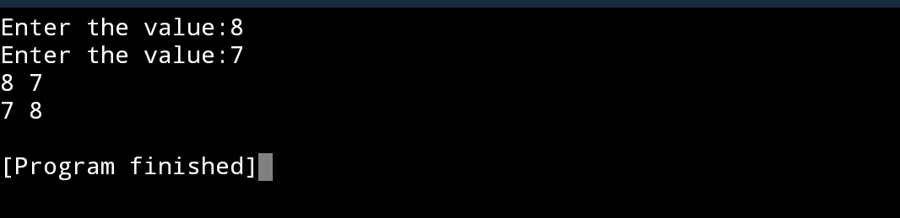

**PROGRAM:**

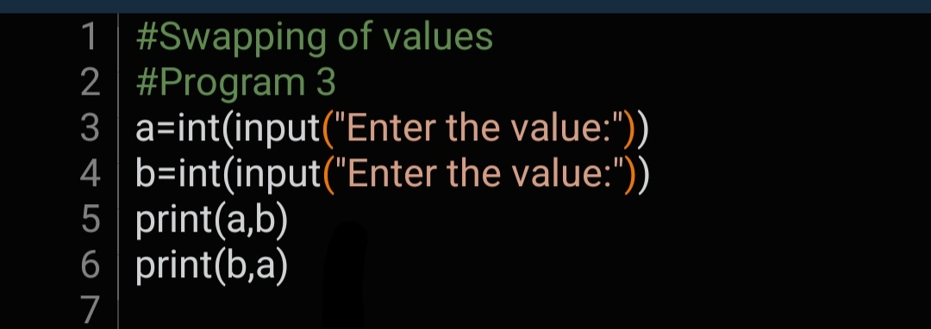

**OUTPUT:**

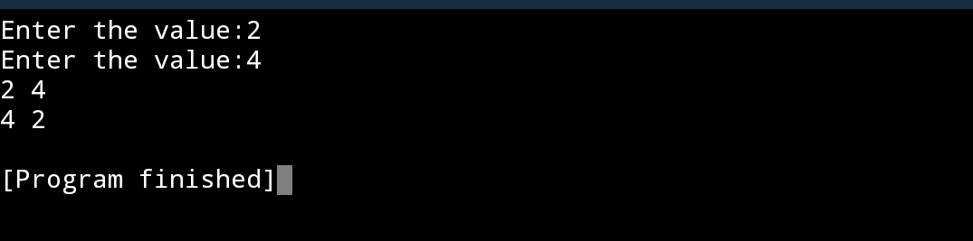

**PROGRAM:**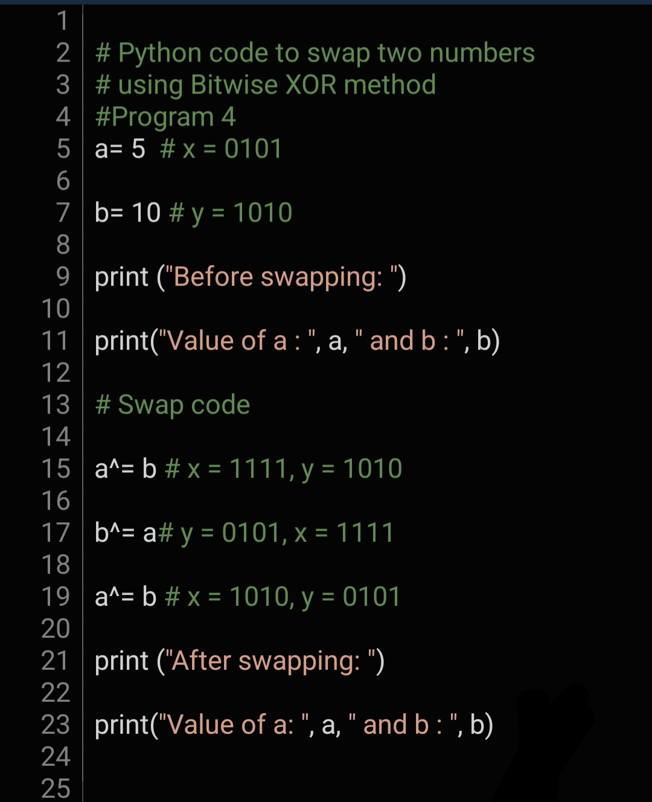

**OUTPUT:**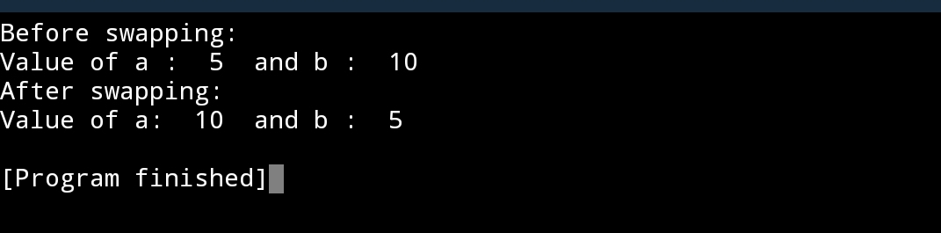

**PROGRAM:**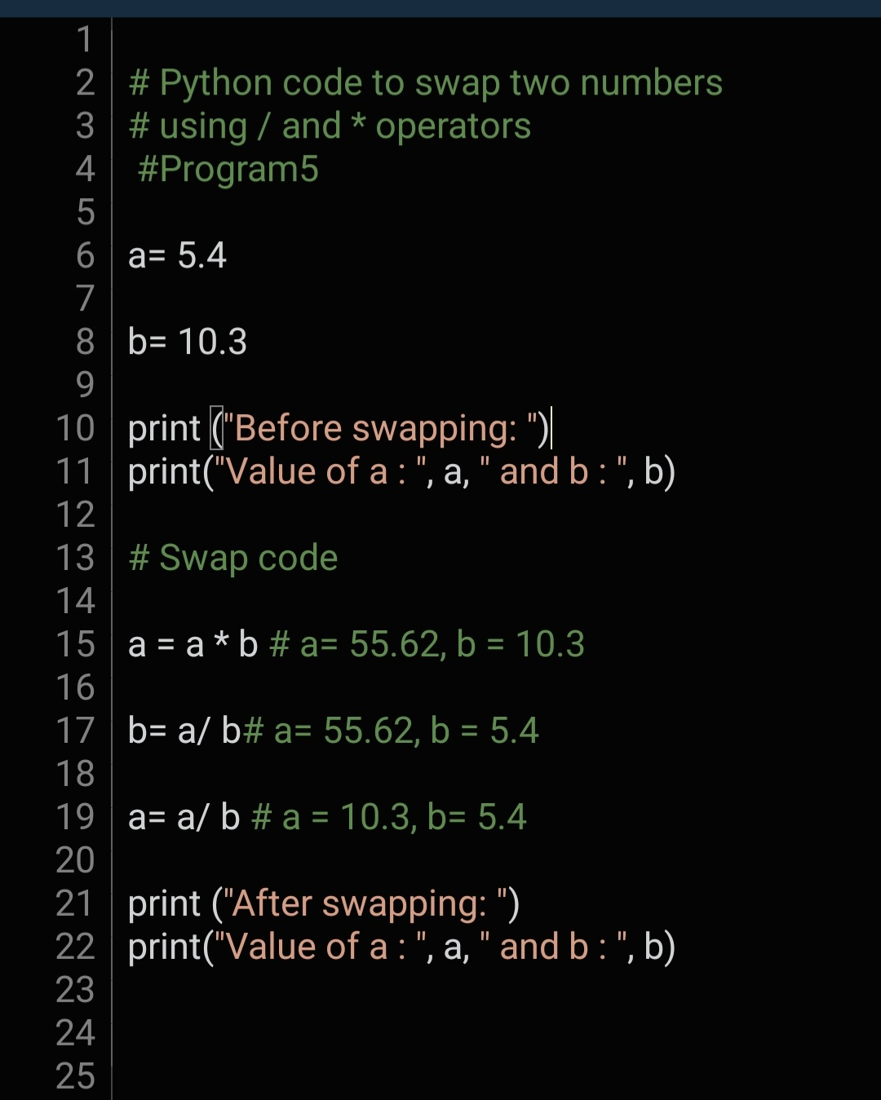

**OUTPUT:E**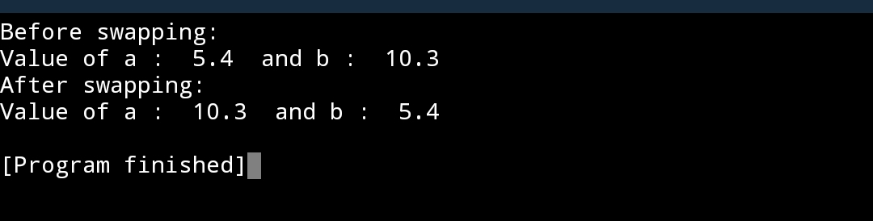

**Ex.no.2g CALCULATE SIMPLE INTEREST**

**PROGRAM:**

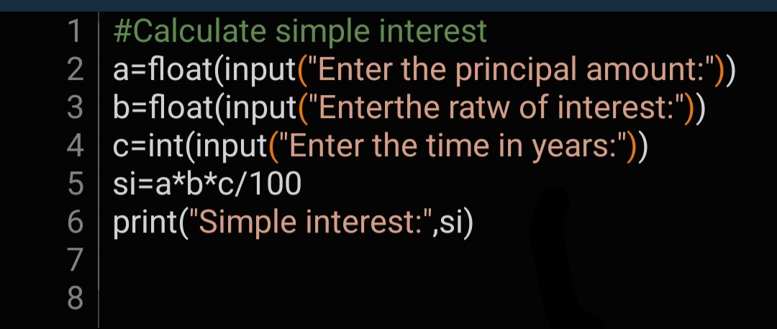

**OUTPUT:**

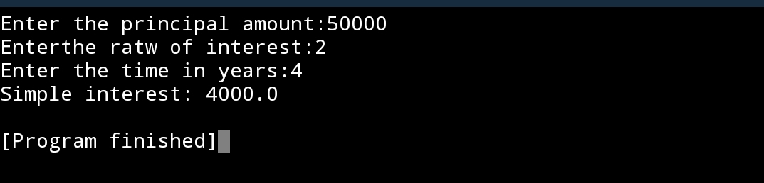

**Ex.no.2h CIRCULATE THE VALUES**

**PROGRAM:**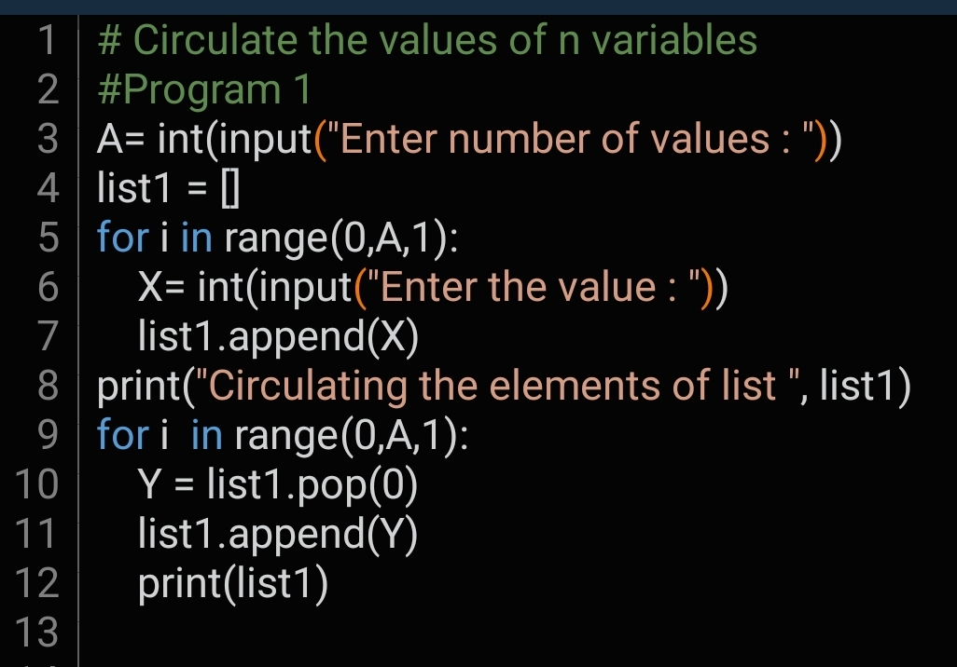

**OUTPUT:**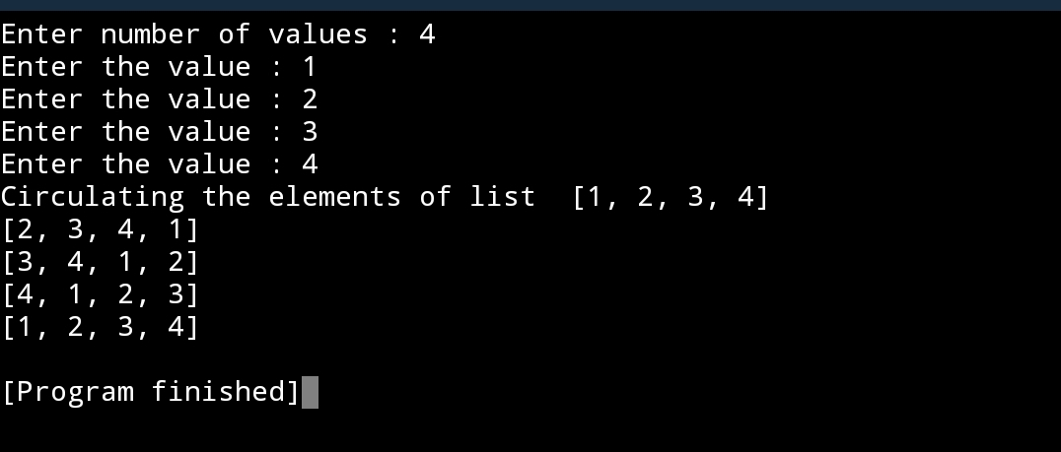

**Ex.no.2i LEAP YEAR OR NOT**

**PROGRAM:**

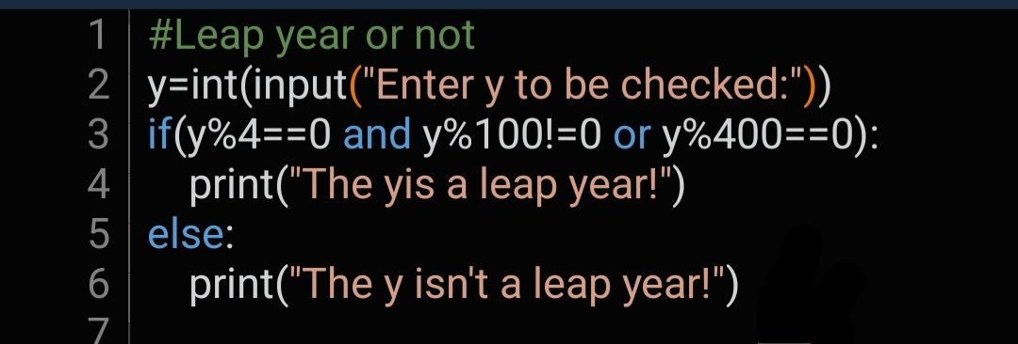

**OUTPUT:**

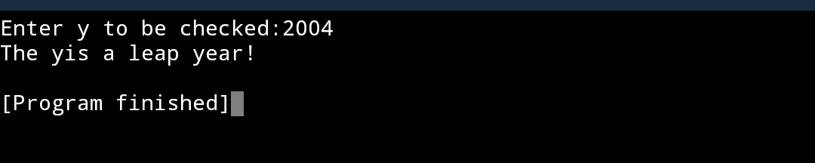

**Ex.no.2j ODD OR EVEN NUMBER**

**PROGRAM:**

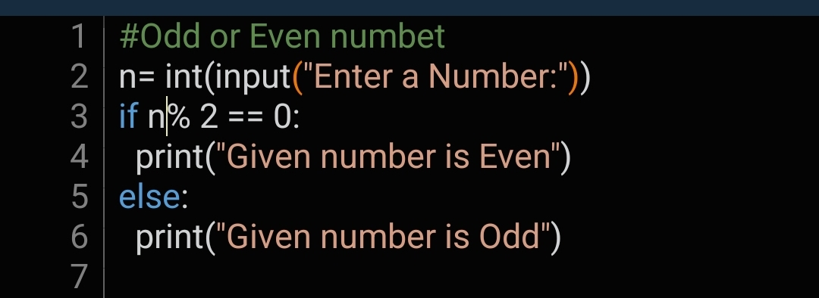

**OUTPUT:**

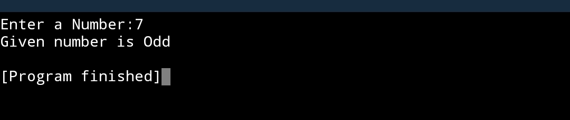

**Ex.no.2k PRIME OR NOT PRIME**

**PROGRAM:**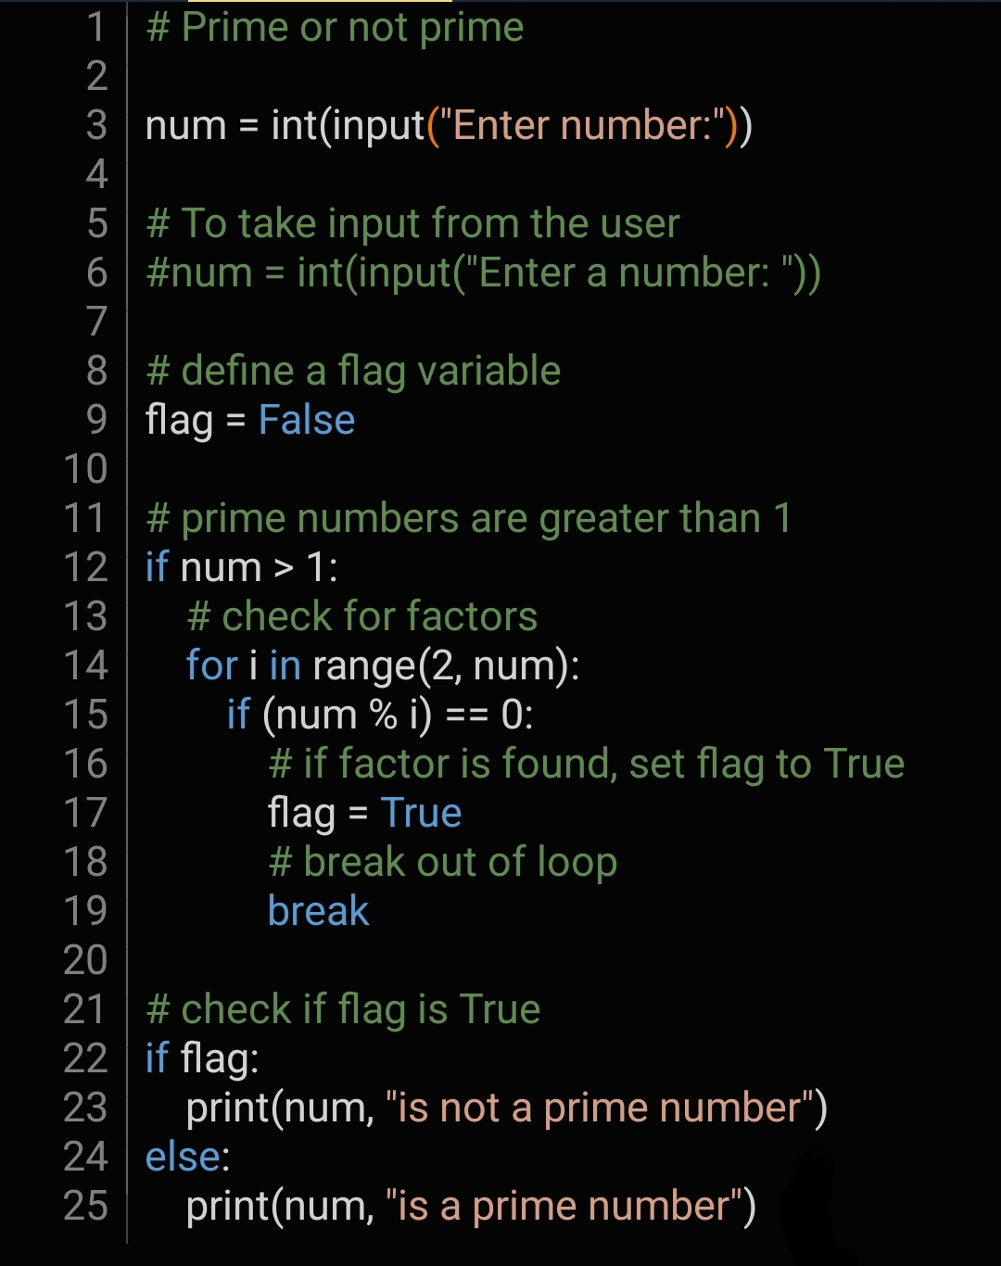

**OUTPUT:**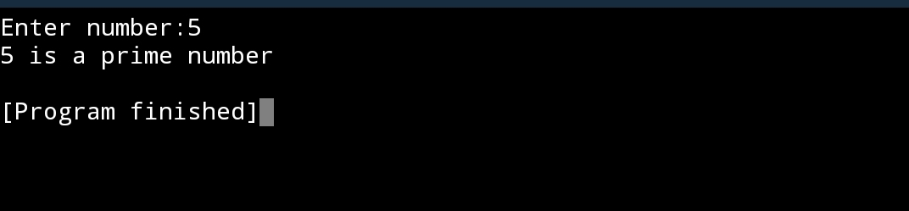

**Ex.no.2l FACTORIAL OF A NUMBER**

**PROGRAM:**

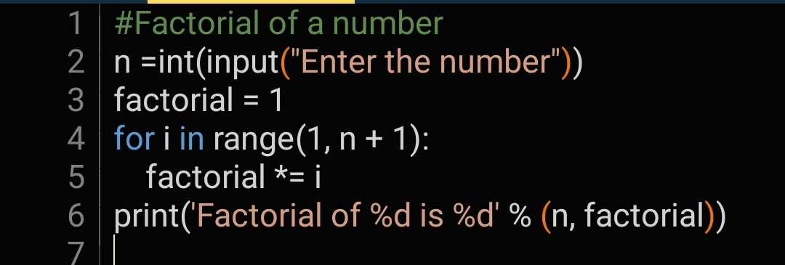

**OUTPUT:**

